**Hands on 1**

**Spring Data JPA - Quick Example**   
  
**Create a Eclipse Project using Spring Initialize:**

**QuickStartApplication.java:**

**package** com.cognizant.quickstart;

**import** org.springframework.beans.factory.annotation.Autowired;

**import** org.springframework.boot.CommandLineRunner;

**import** org.springframework.boot.SpringApplication;

**import** org.springframework.boot.autoconfigure.SpringBootApplication;

**import** com.cognizant.quickstart.model.Country;

**import** com.cognizant.quickstart.service.CountryService;

@SpringBootApplication

**public** **class** QuickStartApplication **implements** CommandLineRunner {

@Autowired

**private** CountryService countryService;

**public** **static** **void** main(String[] args) {

SpringApplication.*run*(QuickStartApplication.**class**, args);

}

@Override

**public** **void** run(String... args) **throws** Exception {

// Create and insert a new country

Country country = **new** Country();

country.setCode("IN");

country.setName("India");

countryService.addCountry(country);

// Fetch and display all countries

System.***out***.println("All countries in database:");

**for** (Country c : countryService.getAllCountries()) {

System.***out***.println(c.getCode() + " - " + c.getName());

}

}

}

**Country.java:**

**package** com.cognizant.quickstart.model;

**import** jakarta.persistence.Entity;

**import** jakarta.persistence.Id;

**import** jakarta.persistence.Table;

@Entity

@Table(name = "country")

**public** **class** Country {

@Id

**private** String code;

**private** String name;

// Getters & Setters

**public** String getCode() {

**return** code;

}

**public** **void** setCode(String code) {

**this**.code = code;

}

**public** String getName() {

**return** name;

}

**public** **void** setName(String name) {

**this**.name = name;

}

}

**CountryRepository.java:**

**package** com.cognizant.quickstart.repository;

**import** org.springframework.data.jpa.repository.JpaRepository;

**import** com.cognizant.quickstart.model.Country;

**public** **interface** CountryRepository **extends** JpaRepository<Country, String> {

// JPA will implement everything automatically

}

**CountryService.java:**

**package** com.cognizant.quickstart.service;

**import** org.springframework.beans.factory.annotation.Autowired;

**import** org.springframework.stereotype.Service;

**import** com.cognizant.quickstart.model.Country;

**import** com.cognizant.quickstart.repository.CountryRepository;

**import** java.util.List;

@Service

**public** **class** CountryService {

@Autowired

**private** CountryRepository countryRepository;

**public** List<Country> getAllCountries() {

**return** countryRepository.findAll();

}

**public** **void** addCountry(Country country) {

countryRepository.save(country);

}

**public** Country getCountry(String code) {

**return** countryRepository.findById(code).orElse(**null**);

}

}

**OUTPUT:**

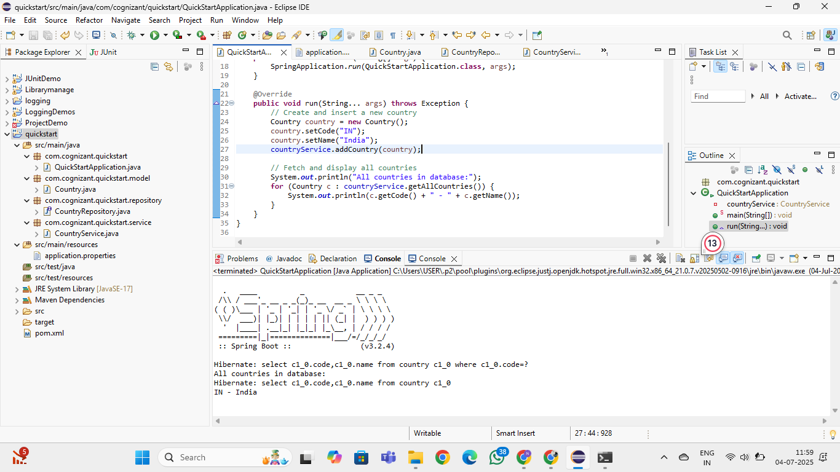

**Hands on 4**

**Difference between JPA, Hibernate and Spring Data JPA**

**SOLUTION:**

**EMPLOYEEAPPAPPLICATION:**

**package** com.example.employeeapp;

**import** com.example.employeeapp.model.Employee;

**import** com.example.employeeapp.service.EmployeeService;

**import** org.springframework.beans.factory.annotation.Autowired;

**import** org.springframework.boot.CommandLineRunner;

**import** org.springframework.boot.SpringApplication;

**import** org.springframework.boot.autoconfigure.SpringBootApplication;

**import** org.springframework.boot.autoconfigure.domain.EntityScan;

@SpringBootApplication

@EntityScan(basePackages = "com.example.employeeapp.model")

**public** **class** EmployeeAppApplication **implements** CommandLineRunner {

@Autowired

**private** EmployeeService employeeService;

**public** **static** **void** main(String[] args) {

SpringApplication.*run*(EmployeeAppApplication.**class**, args);

}

@Override

**public** **void** run(String... args) {

Employee e = **new** Employee();

e.setName("Alice");

e.setRole("Developer");

e.setSalary(70000);

employeeService.addEmployee(e);

System.***out***.println("✅ Employee inserted.");

}

}

**EMPLOYEE.JAVA:**

**package** com.example.employeeapp.model;

**import** jakarta.persistence.*;

@Entity

@Table(name = "employee") // Optional but good to be explicit

**public** **class** Employee {

@Id

@GeneratedValue(strategy = GenerationType.***IDENTITY***)

**private** **int** id;

**private** String name;

**private** String role;

**private** **int** salary;

// Getters and Setters

**public** **int** getId() {

**return** id;

}

**public** **void** setId(**int** id) {

**this**.id = id;

}

**public** String getName() {

**return** name;

}

**public** **void** setName(String name) {

**this**.name = name;

}

**public** String getRole() {

**return** role;

}

**public** **void** setRole(String role) {

**this**.role = role;

}

**public** **int** getSalary() {

**return** salary;

}

**public** **void** setSalary(**int** salary) {

**this**.salary = salary;

}

}

**EMPLOYEEREPOSITORY.JAVA:**

**package** com.example.employeeapp.repository;

**import** org.springframework.data.jpa.repository.JpaRepository;

**import** com.example.employeeapp.model.Employee;

**public** **interface** EmployeeRepository **extends** JpaRepository<Employee, Integer> {

}

**EMPLOYEESERVICE.JAVA:**

**package** com.example.employeeapp.service;

**import** org.springframework.beans.factory.annotation.Autowired;

**import** org.springframework.stereotype.Service;

**import** org.springframework.transaction.annotation.Transactional;

**import** com.example.employeeapp.model.Employee;

**import** com.example.employeeapp.repository.EmployeeRepository;

@Service

**public** **class** EmployeeService {

@Autowired

**private** EmployeeRepository employeeRepository;

@Transactional

**public** **void** addEmployee(Employee employee) {

employeeRepository.save(employee);

}

}

